Task 5 : Working with SLURM - Scripting & Kubeflow

Date: 27-03-2026

PART 1 — SLURM

Procedure
This experiment was conducted to understand job scheduling using the SLURM workload manager in a containerized setup. A SLURM cluster was deployed using Docker, which included a controller node and compute nodes. The objective was to execute a Python-based matrix addition program as a batch job. The process involved cluster setup, verification of node availability, creation of a Python script, preparation of a SLURM job file, submission of the job, and validation of output results.
Step-by-Step Explanation
The SLURM cluster was initialized using a Docker-based repository.

git clone https://github.com/giovtorres/slurm-docker-cluster.git
cd slurm-docker-cluster
docker compose up -d

The running containers were verified:

docker ps
docker exec -it slurmctld bash
sinfo

A Python program was created to perform matrix addition:

A = [[1, 2], [3, 4]]
B = [[5, 6], [7, 8]]

result = [[A[i][j] + B[i][j] for j in range(2)] for i in range(2)]
print(result)
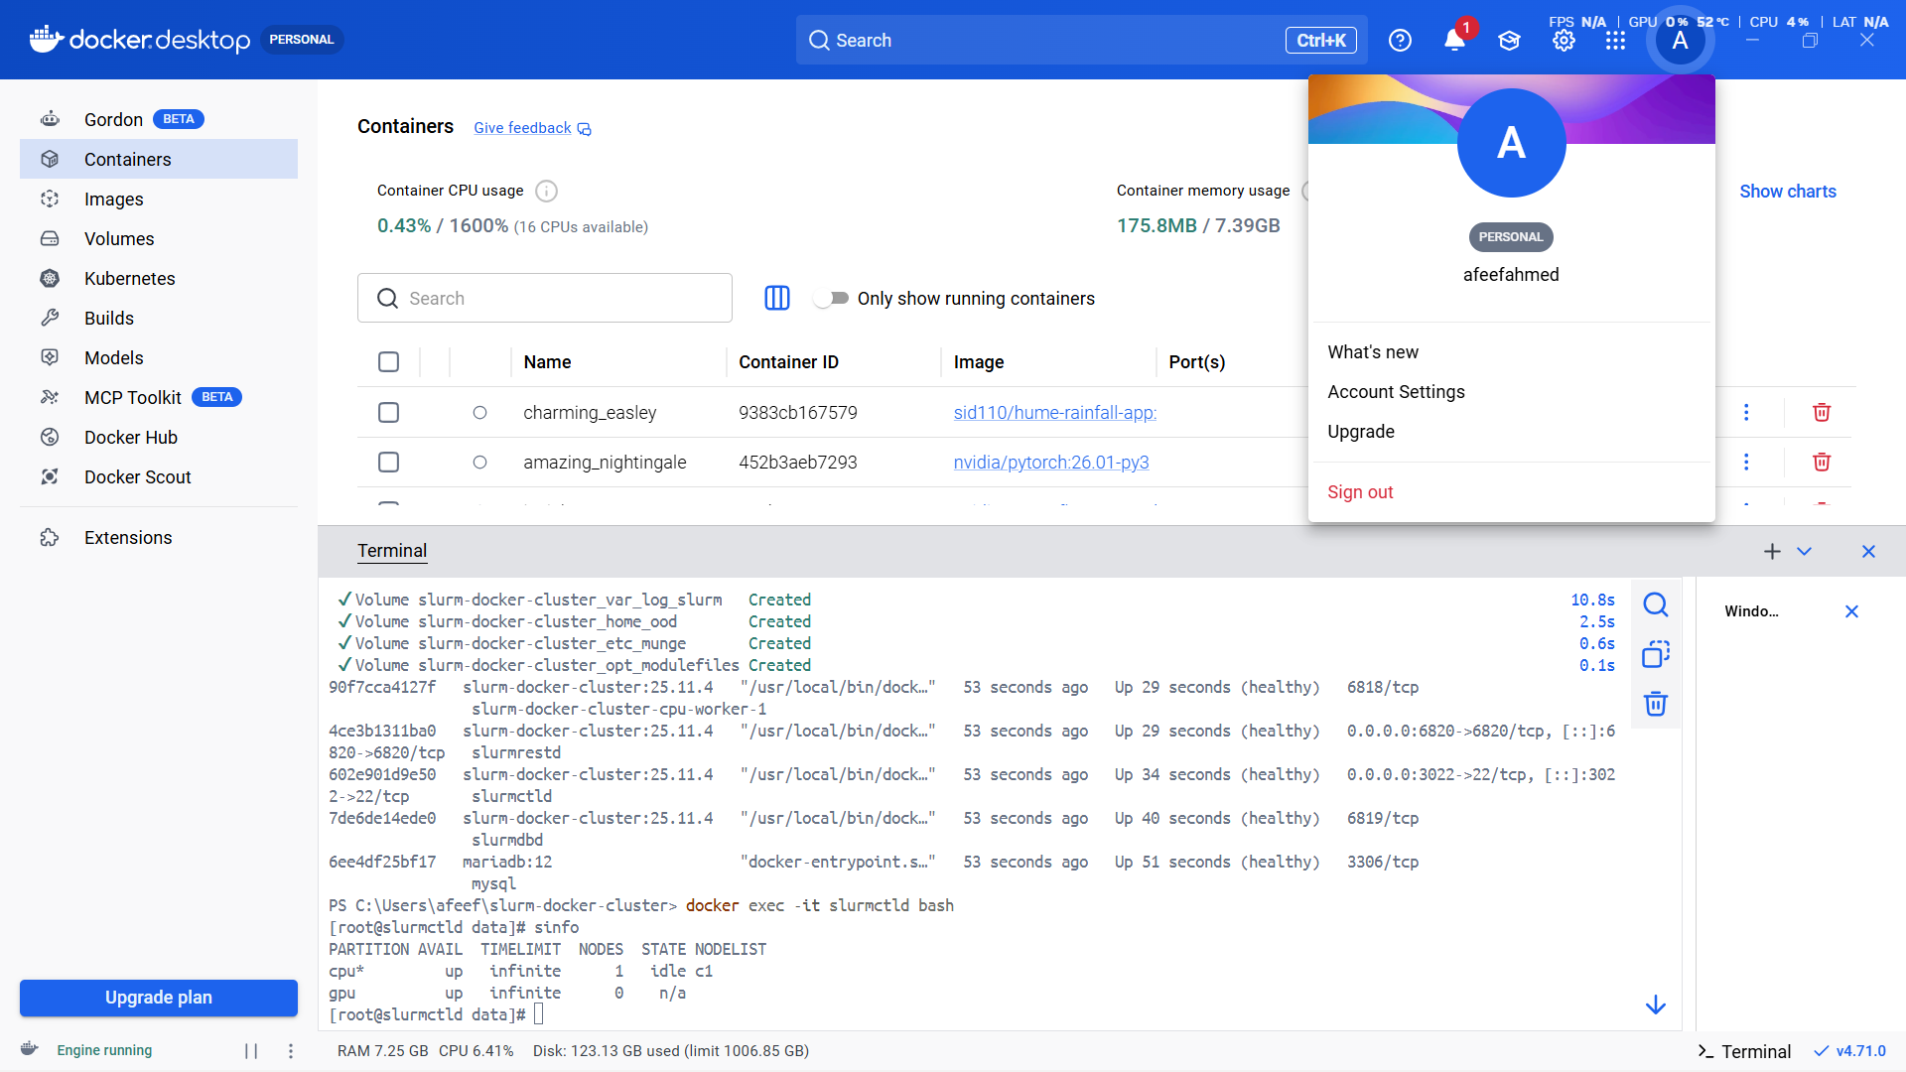

Fig 33: Docker Containers Running (SLURM Cluster)



Fig 34: SLURM Cluster Status (sinfo)

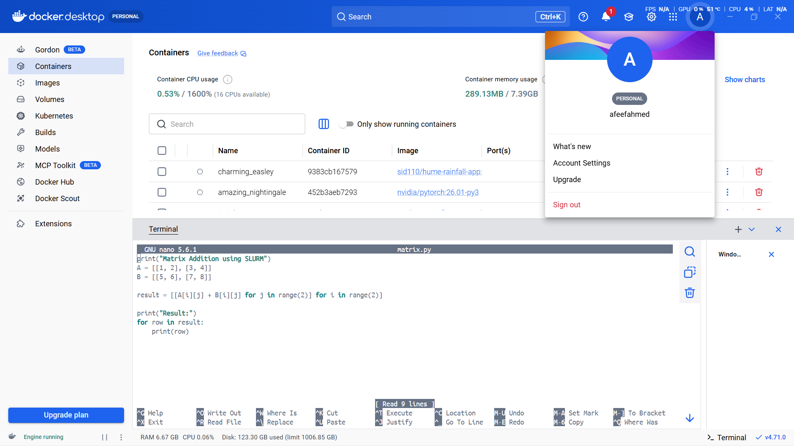

Fig 35: Matrix Program in SLURM
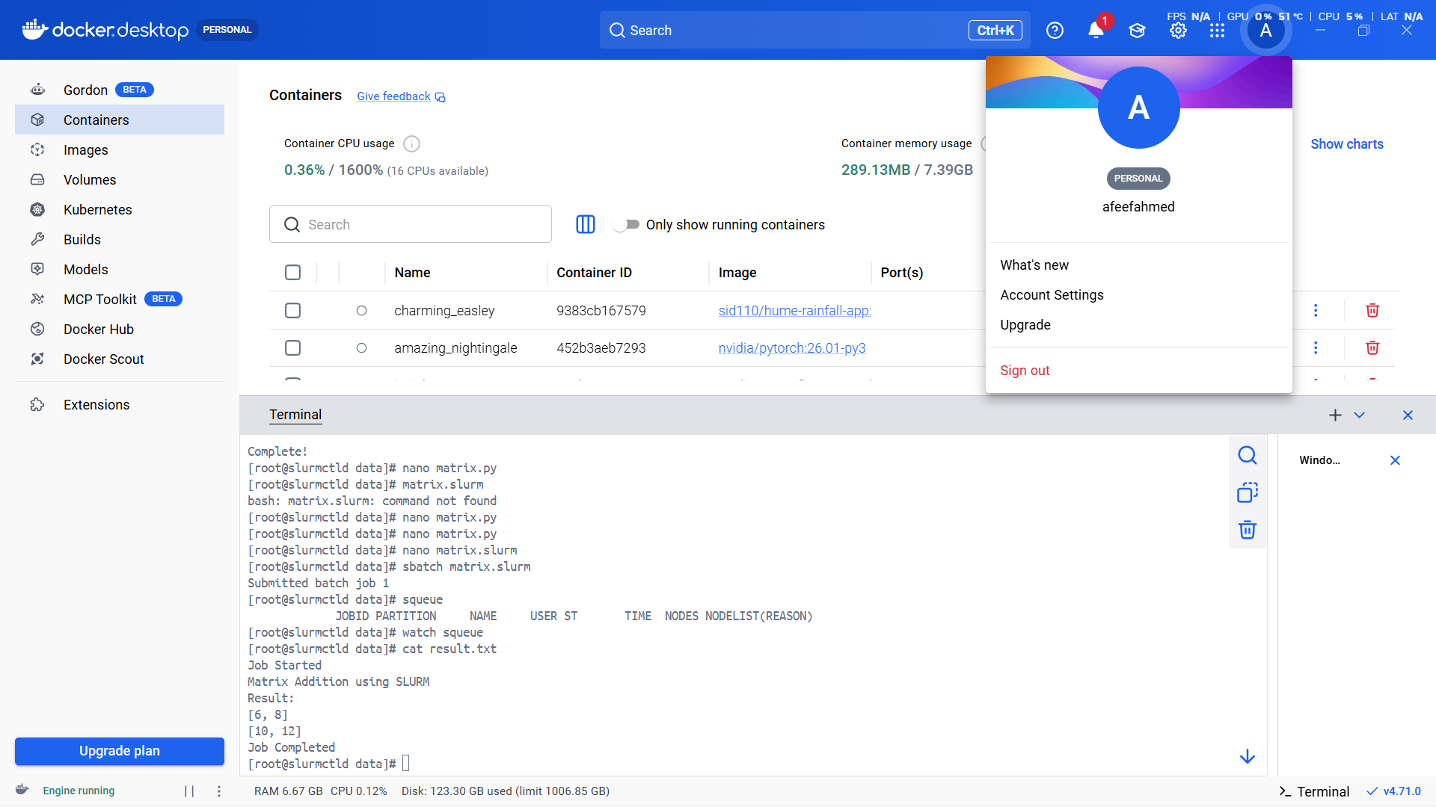

Fig 36: SLURM Job Output

A SLURM batch script was written:

#!/bin/bash
#SBATCH --job-name=matrix_add
#SBATCH --output=result.txt
python3 matrix.py

The job was submitted:

sbatch matrix.slurm
cat result.txt

The successful output confirmed that SLURM correctly scheduled and executed the job, demonstrating effective resource allocation and batch processing.

PART 2 — Kubeflow

Procedure
This experiment focused on workflow automation using Kubeflow Pipelines. The objective was to create a reusable pipeline component for matrix addition and compile it into a YAML workflow file. This demonstrated how machine learning workflows can be modularized and automated.
Step-by-Step Explanation
The Kubeflow Pipelines SDK was installed to enable pipeline creation:

pip install kfp

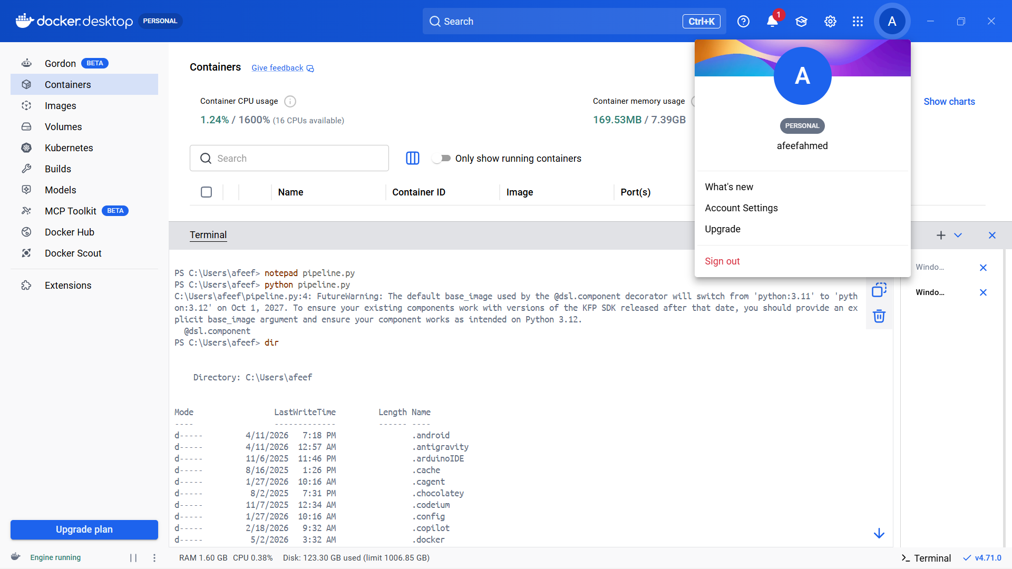Fig 38:Kubeflow Pipeline Script

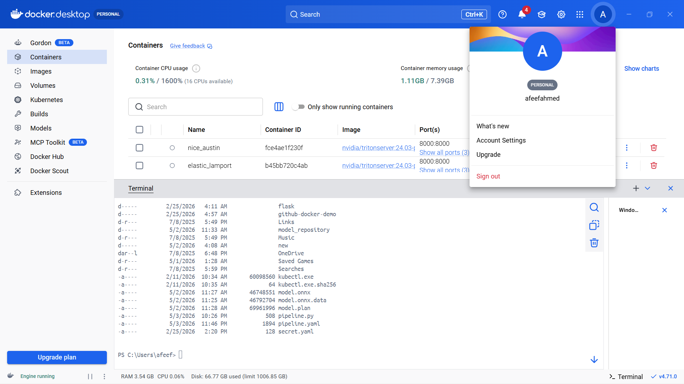

Fig 39:Kubeflow Pipeline YAML Listing
A Python script was written to define a reusable component for matrix addition. The component encapsulated the logic of matrix operations:

from kfp import dsl
from kfp.compiler import Compiler

@dsl.component
def matrix_addition():
print("Matrix Addition using Kubeflow")

A = [[1, 2], [3, 4]]
B = [[5, 6], [7, 8]]

result = [[A[i][j] + B[i][j] for j in range(2)] for i in range(2)]

print("Result:")
for row in result:
print(row)

@dsl.pipeline(name="matrix-addition-pipeline")
def pipeline():
matrix_addition()

Execution:

python pipeline.py

This generated pipeline.yaml, confirming successful pipeline creation.

Task 6 : Using Jupyter Notebook and PyTorch for Tensor Operations and Data-Centric Application

Date: 08-04-2026

Procedure
This experiment was conducted to understand tensor operations and implement a simple data-centric application using PyTorch in a Jupyter Notebook environment. The process involved installing the required libraries, launching the notebook interface, performing tensor computations, and building a simple linear regression model. This experiment demonstrated how PyTorch can be used both for mathematical operations and for training machine learning models.
Step-by-Step Explanation
The experiment began by installing the required libraries and launching Jupyter Notebook from the terminal. This provided an interactive environment for executing Python code:

pip install notebook torch torchvision
jupyter notebook

A new Python notebook was created, and tensor operations were performed using PyTorch. Two tensors were defined, and basic operations such as addition, subtraction, element-wise multiplication, and matrix multiplication were carried out.

import torch

a = torch.tensor([[1, 2], [3, 4]])
b = torch.tensor([[5, 6], [7, 8]])

print("Addition:\n", a + b)
print("Subtraction:\n", a - b)
print("Element-wise Multiplication:\n", a * b)
print("Matrix Multiplication:\n", torch.matmul(a, b))

After performing tensor operations, a simple data-centric application was implemented using linear regression. A dataset representing a linear relationship was created, and a model was defined using PyTorch.

import torch.nn as nn
import torch.optim as optim

x = torch.tensor([[1.0], [2.0], [3.0], [4.0]])
y = torch.tensor([[3.0], [5.0], [7.0], [9.0]])

model = nn.Linear(1, 1)
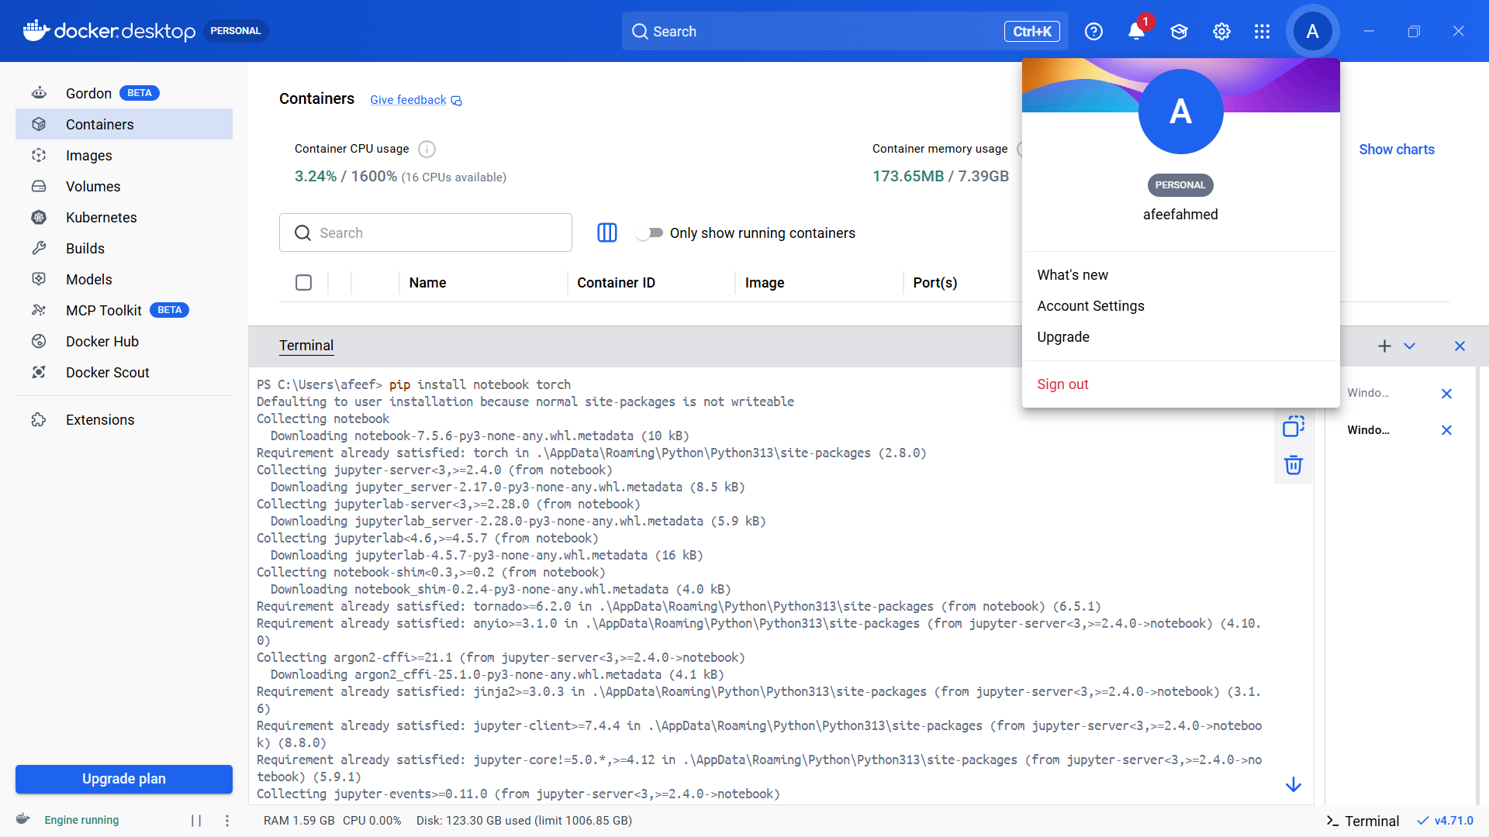

Fig 40:Jupyter Installation Process

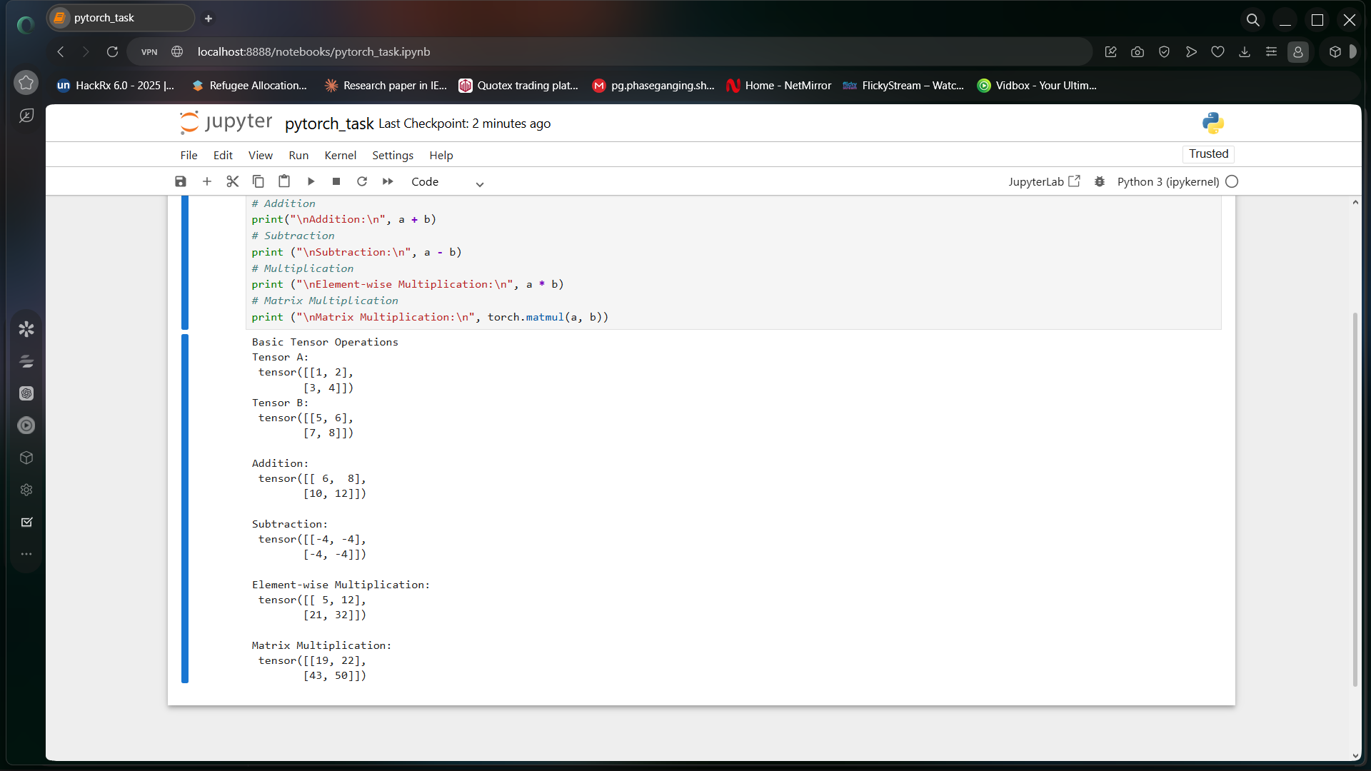

Fig 41:Jupyter Tensor Output

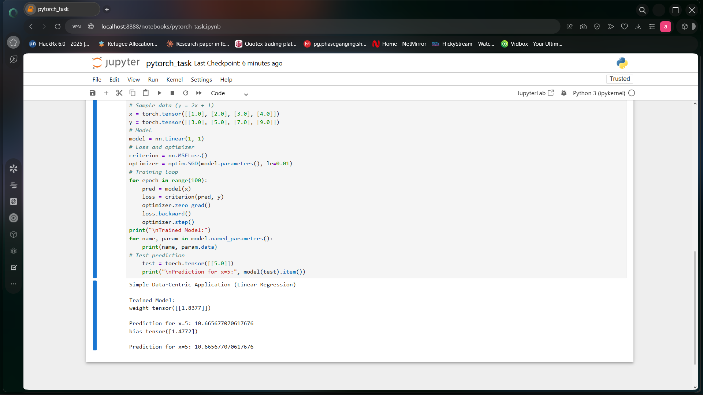

Fig 42:Linear Regression Output

A loss function and optimizer were defined, and the model was trained using an iterative loop.

criterion = nn.MSELoss()
optimizer = optim.SGD(model.parameters(), lr=0.01)

for epoch in range(100):
pred = model(x)
loss = criterion(pred, y)

optimizer.zero_grad()
loss.backward()
optimizer.step()

Finally, the trained model was tested using a new input value to verify its prediction accuracy.

test = torch.tensor([[5.0]])
print("Prediction for x=5:", model(test).item())

The experiment successfully demonstrated tensor operations and model training using PyTorch.

Task 7 : Testing the GPGPU Computing

Date: 21-04-2026

Procedure
This experiment was performed to analyze and compare the performance of CPU-based and GPU-based computations using PyTorch. The aim was to demonstrate how GPUs improve performance for large-scale computations through parallel processing.
Step-by-Step Explanation
The experiment began by verifying whether a GPU was available in the system using PyTorch. This ensured that computations could be offloaded to the CUDA-enabled device.

import torch

print("GPU Available:", torch.cuda.is_available())

A large dataset was generated to simulate a computationally intensive task. The sorting operation was first performed on the CPU, and execution time was recorded.
import time

data = torch.rand(10_000_000)

start = time.time()
torch.sort(data)
cpu_time = time.time() - start

print("CPU Time:", cpu_time)

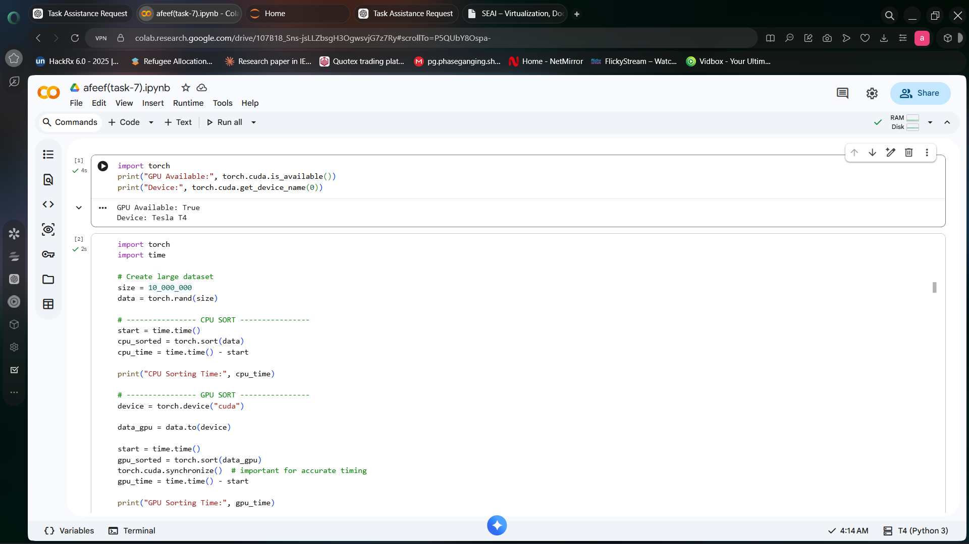

Fig 43:GPU Verification Output

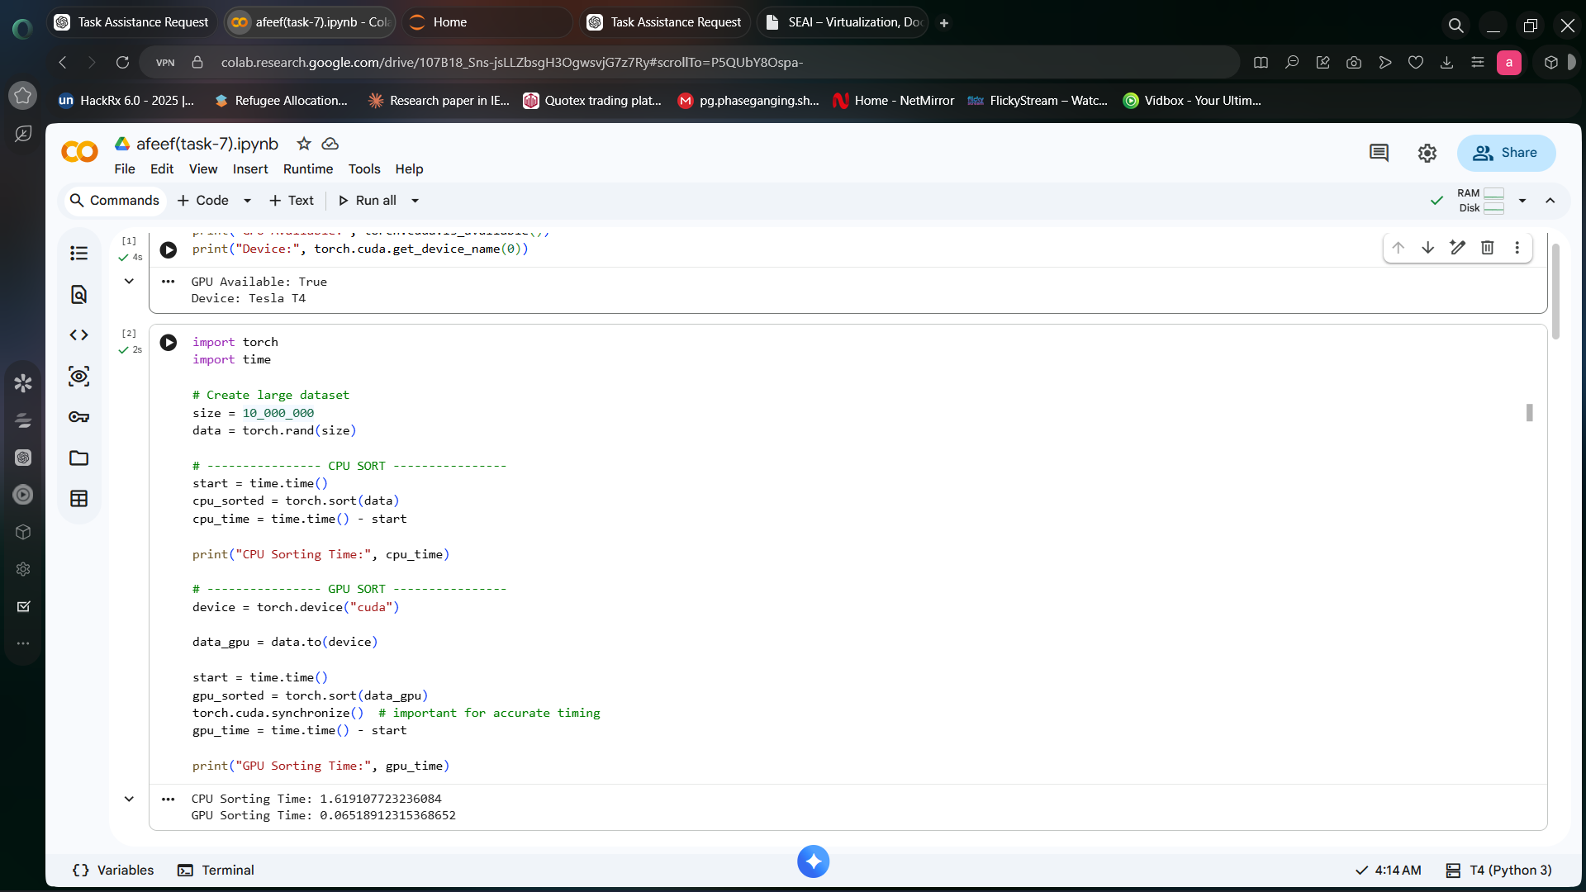

Fig 44:GPU Sorting Output
The same dataset was then transferred to the GPU, and the sorting operation was repeated. Synchronization was used to ensure accurate timing.

device = torch.device("cuda")

data_gpu = data.to(device)

start = time.time()
torch.sort(data_gpu)
torch.cuda.synchronize()
gpu_time = time.time() - start

print("GPU Time:", gpu_time)

The results showed that GPU execution was significantly faster for large datasets, demonstrating the advantages of parallel computing.

Task 8 : Testing CUDA-X Tensor Operations, Mixed Precision, and Quantization-Aware Training using PyTorch

Date: 25-04-2026

Procedure
This experiment explored advanced GPU computing techniques using PyTorch, including CUDA tensor operations, automatic differentiation, mixed precision training, and quantization-aware training. The aim was to analyze performance improvements and efficiency in deep learning workflows.
Step-by-Step Explanation
The experiment began by setting up the device to use GPU if available.

import torch

device = torch.device("cuda" if torch.cuda.is_available() else "cpu")
print("Using:", device)

Large tensors were created directly on the GPU, and matrix multiplication was performed.

A = torch.randn(4096, 4096, device=device)
B = torch.randn(4096, 4096, device=device)

C = A @ B
print("Matrix multiplication completed")
Automatic differentiation was demonstrated using PyTorch autograd.

x = torch.tensor(2.0, requires_grad=True)
y = x**3 + 2*x**2 + x

dy_dx = torch.autograd.grad(y, x, create_graph=True)[0]
d2y_dx2 = torch.autograd.grad(dy_dx, x)[0]

print("First derivative:", dy_dx.item())
print("Second derivative:", d2y_dx2.item())
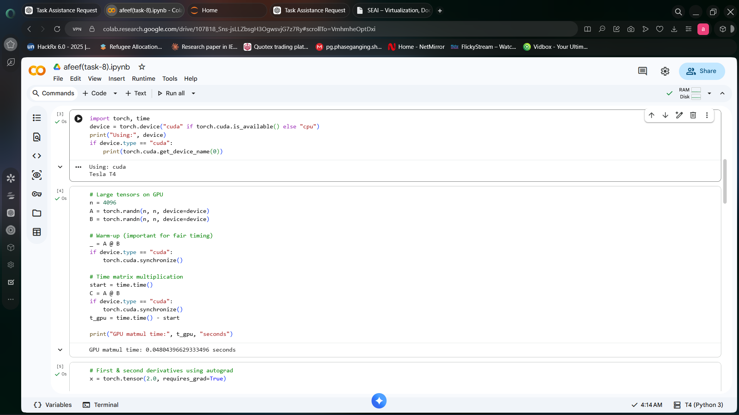

Fig 45:GPU Tensor Operations

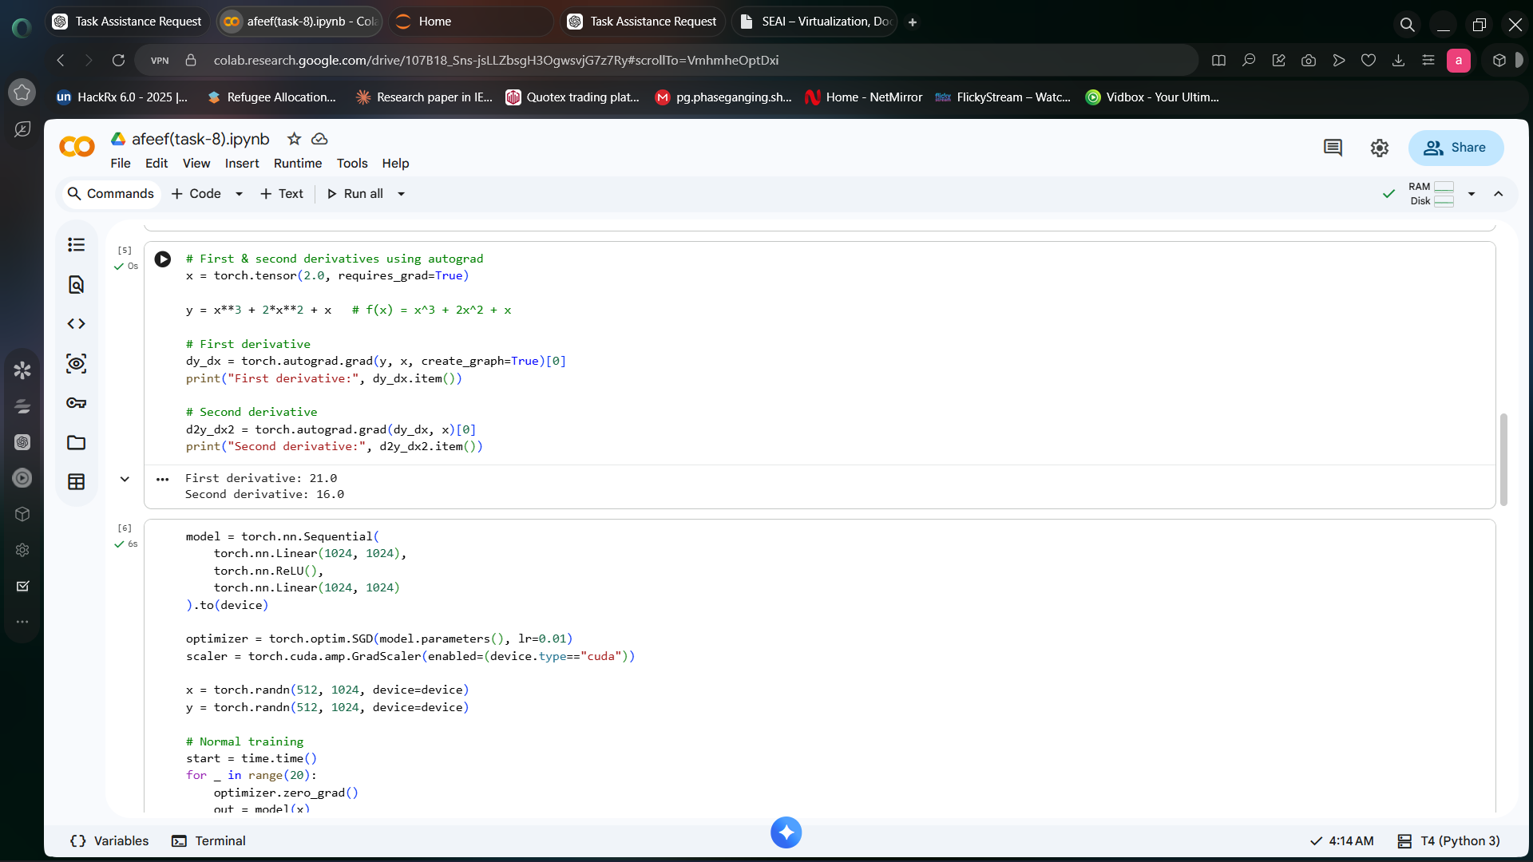

Fig 46:Autograd Derivatives Output

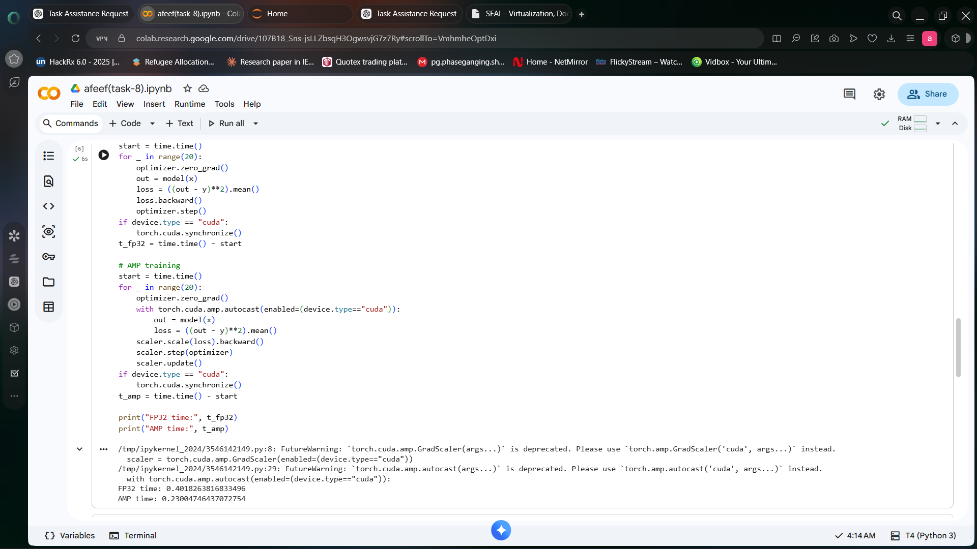

Fig 47:AMP Performance Output

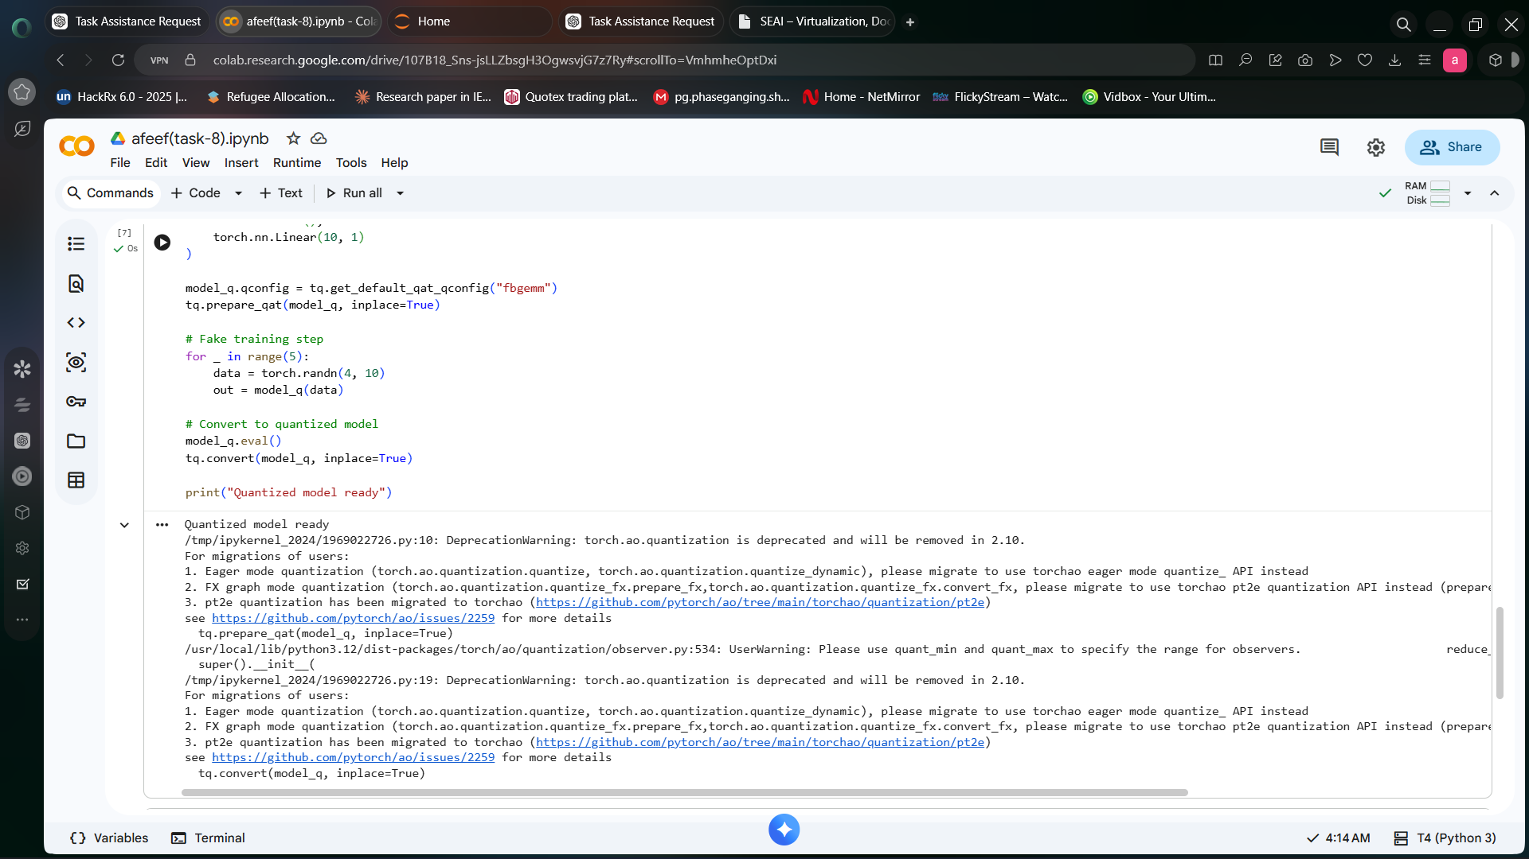

Fig 48:Quantization Output

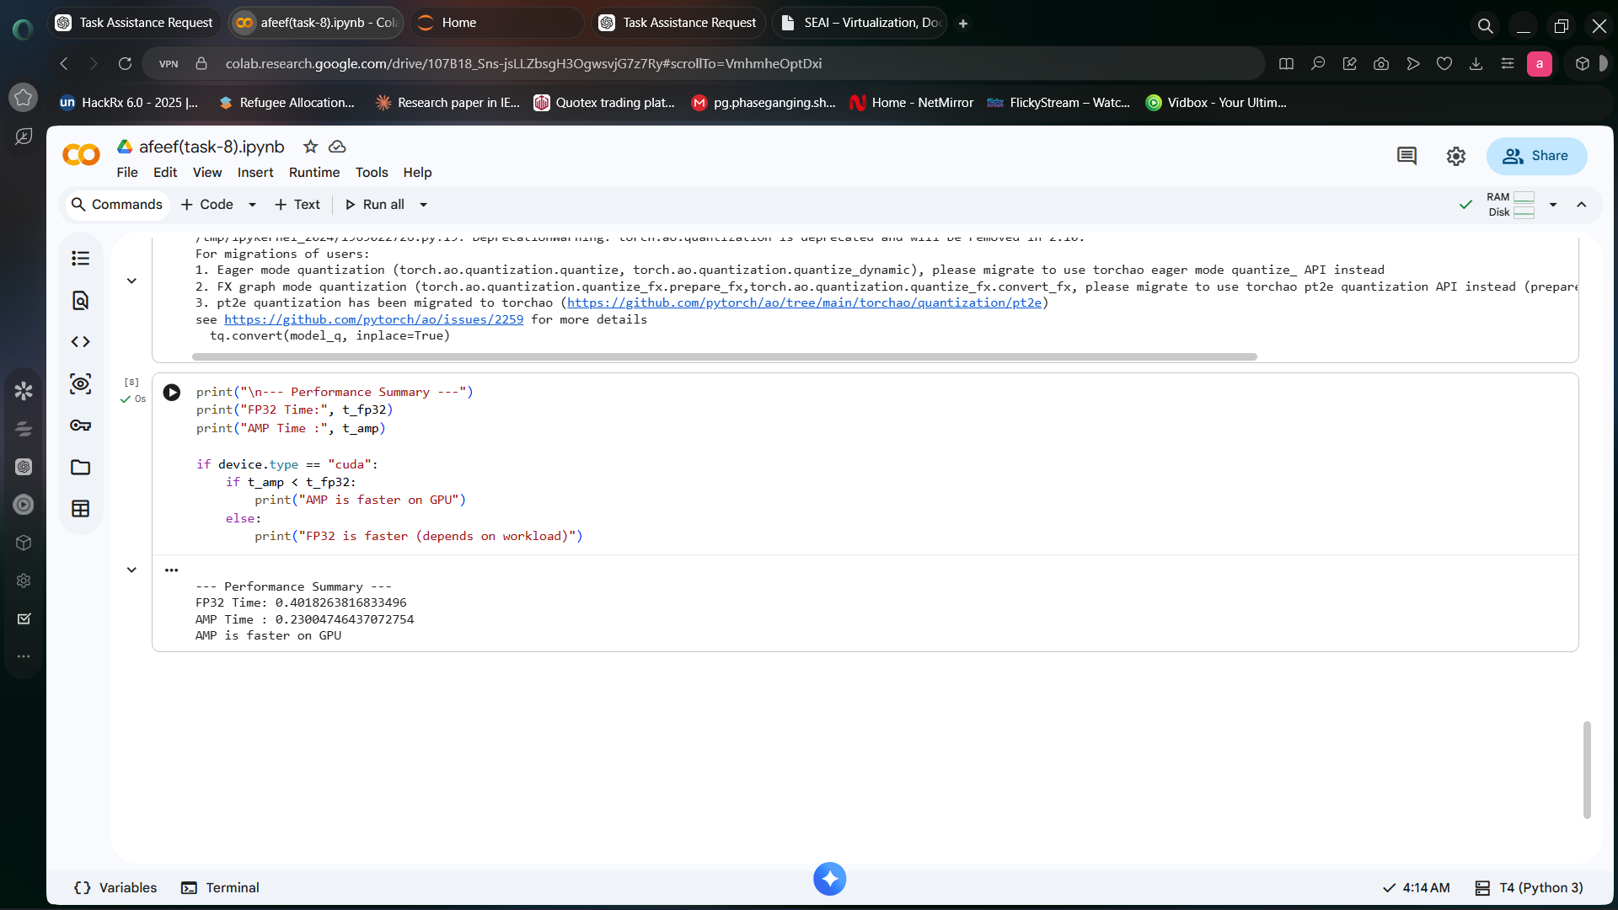

Fig 49:Performance Summary Output

Mixed Precision (AMP) was implemented to improve performance.

from torch.cuda.amp import autocast

with autocast():
result = A @ B

print("AMP computation completed")

Quantization-aware training was demonstrated using PyTorch quantization tools.

import torch.quantization as tq

model = torch.nn.Linear(10, 1)
model.qconfig = tq.get_default_qat_qconfig("fbgemm")

tq.prepare_qat(model, inplace=True)
tq.convert(model, inplace=True)

print("Quantization completed")

Then quantization aware training was demonstrated using the PyTorch Quantization tools. A model was prepared, trained for a short time, and then the model was turned into a quantized one.

import torch.quantization as tq
model_q = torch.nn.Sequential(
torch.nn.Linear(10, 10),
torch.nn.ReLU(),
torch.nn.Linear(10, 1)
)
model_q.qconfig = tq.get_default_qat_qconfig("fbgemm")
tq.prepare_qat(model_q, inplace=True)
for _ in range(5):
data = torch.randn(4, 10)
out = model_q(data)
model_q.eval()
tq.convert(model_q, inplace=True)
print("Quantized model ready")

This experiment showed improved efficiency and reduced computation cost.

Task 9 : Accelerating Neural Network Inferencing: TensorRT & Triton Inference Server

Date: 28-04-2026

Procedure
This experiment was conducted to accelerate neural network inference by converting a PyTorch model into a TensorRT optimized engine and deploying it using Triton Inference Server. The experiment included model conversion, repository setup, server deployment, and inference testing.

Step-by-Step Explanation
A PyTorch model was created and exported to ONNX format.

import os
os.environ["TORCH_ONNX_USE_DYNAMO"] = "0"

import torch
import torchvision.models as models

model = models.resnet18(pretrained=True)
model.eval()

dummy_input = torch.randn(1,3,224,224)

torch.onnx.export(model, dummy_input, "model.onnx", opset_version=11)

The ONNX model was converted into a TensorRT engine.

trtexec --onnx=model.onnx --saveEngine=model.plan

A model repository was created and the engine file was placed inside it.

model_repository/
└── my_model/
└── 1/
└── model.plan

A configuration file was created to define model inputs and outputs.

name: "my_model"
platform: "tensorrt_plan"
max_batch_size: 1

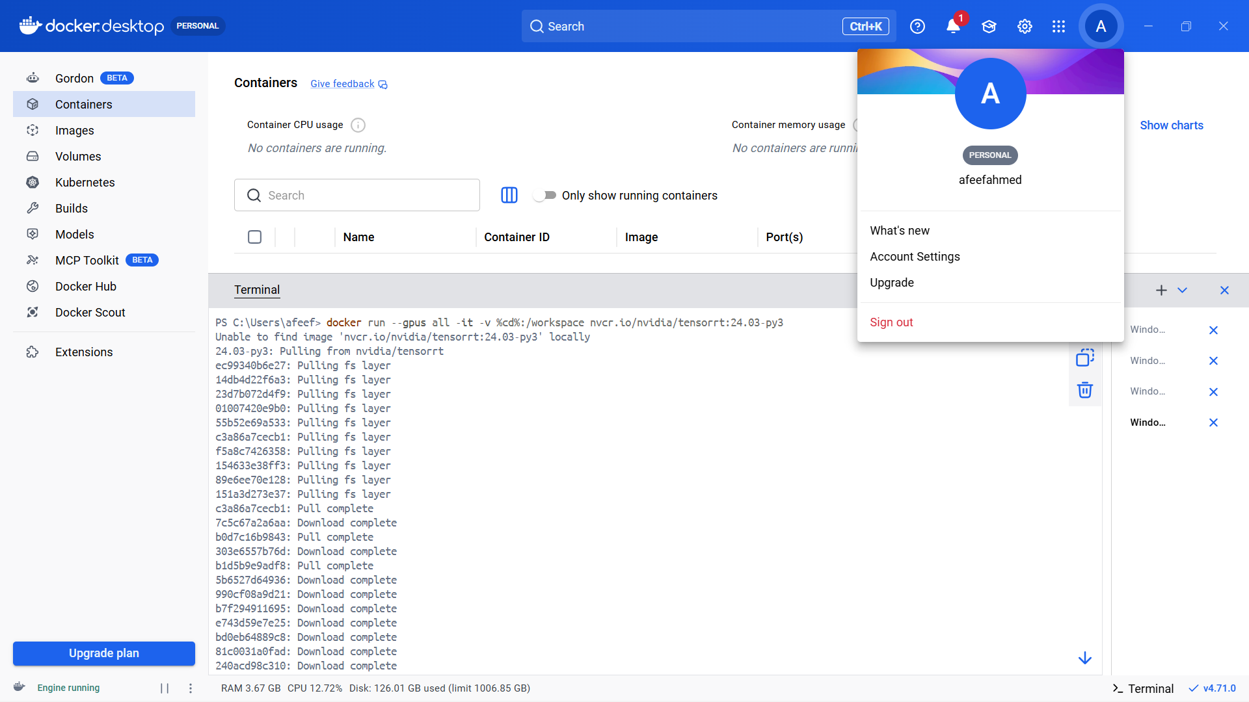
Fig 50:Triton Docker Pull

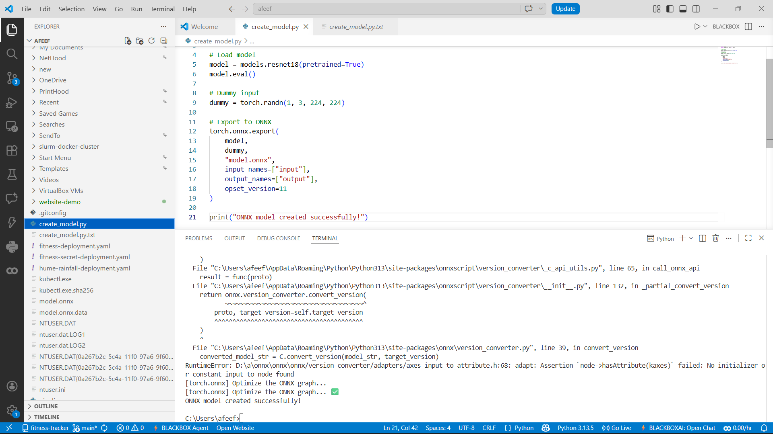

Fig 51:ONNX Model Script



Fig 52:ONNX Model Created

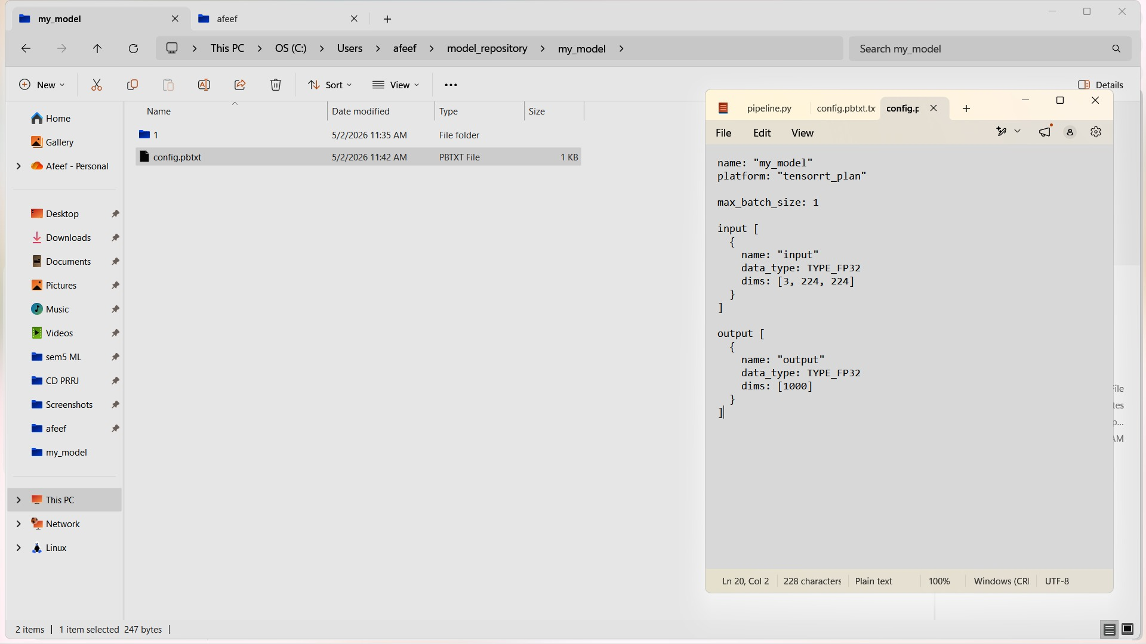

Fig 53:Triton Config File

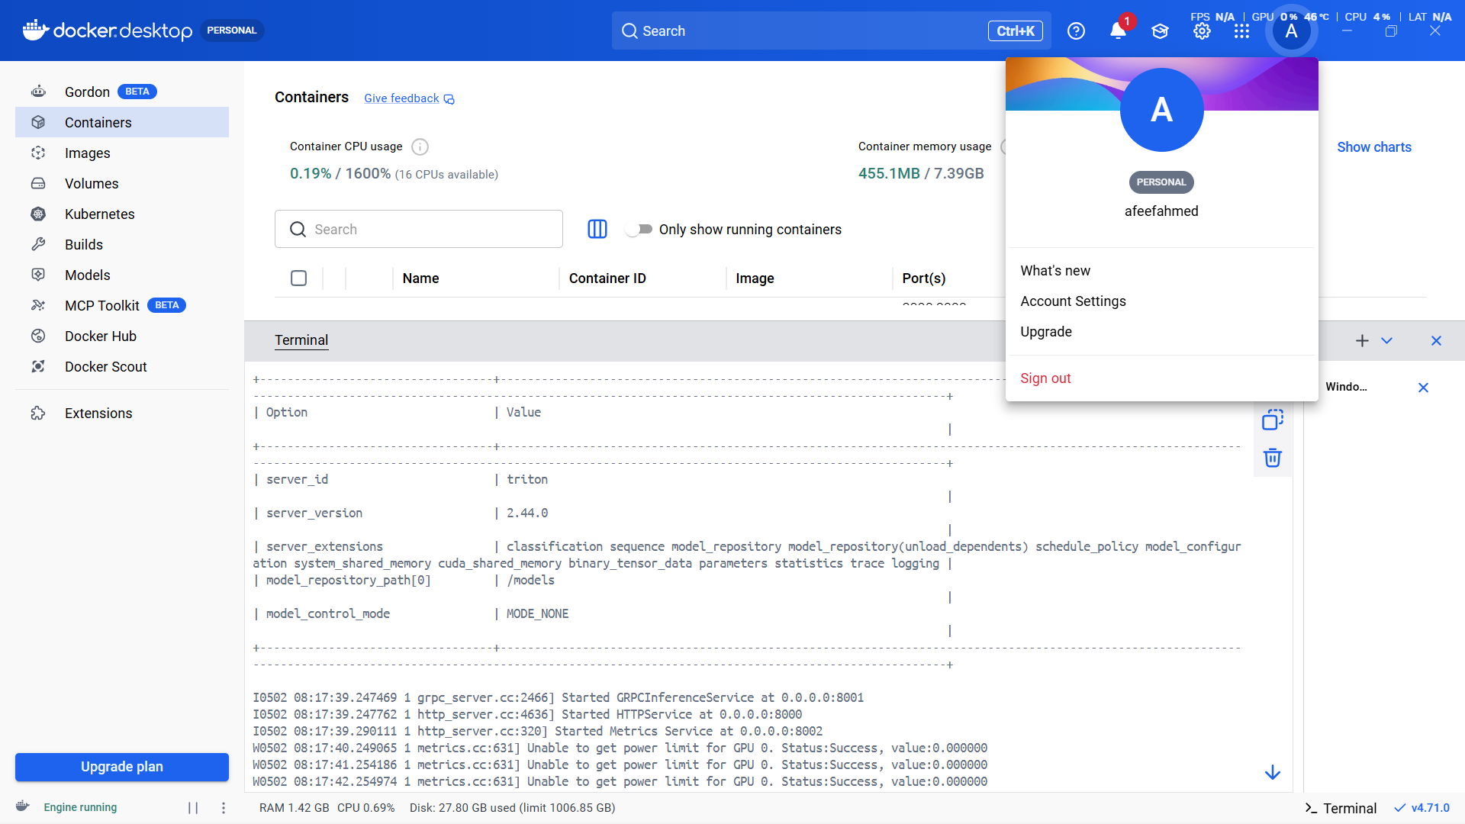

Fig 54:Triton Server Running and status

The Triton server was launched using Docker.

docker run --gpus all -p8000:8000 -p8001:8001 -p8002:8002 -v C:\Users\afeef\model_repository:/models nvcr.io/nvidia/tritonserver:24.03-py3 tritonserver --model-repository=/models

The server status was verified.

curl http://localhost:8000/v2/health/ready -UseBasicParsing

The model was successfully deployed and inference was accelerated using GPU.

Task 10 : Monitoring Load Balancers & Schedulers using Docker with Jupyter, Prometheus, and Grafana

Date: 01-5-2026

Procedure
This experiment was conducted to deploy monitoring services using Docker Compose and visualize system performance using Prometheus and Grafana. A Jupyter Notebook was used to generate computational load.
Step-by-Step Explanation
A project directory was created, and a Docker Compose file was defined.

mkdir exp10
cd exp10

The Docker Compose file included services such as Jupyter, Prometheus, Grafana, and Node Exporter.

version: '3'

services:
jupyter:
image: jupyter/base-notebook
ports: ["8888:8888"]

prometheus:
image: prom/prometheus
ports: ["9090:9090"]

grafana:
image: grafana/grafana
ports: ["3000:3000"]

node-exporter:
image: prom/node-exporter
ports: ["9100:9100"]

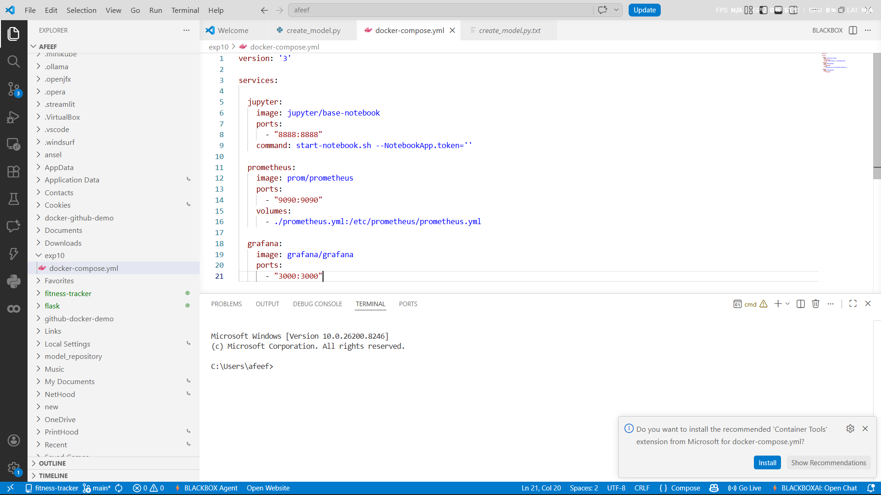

Fig 60:Docker Compose Config

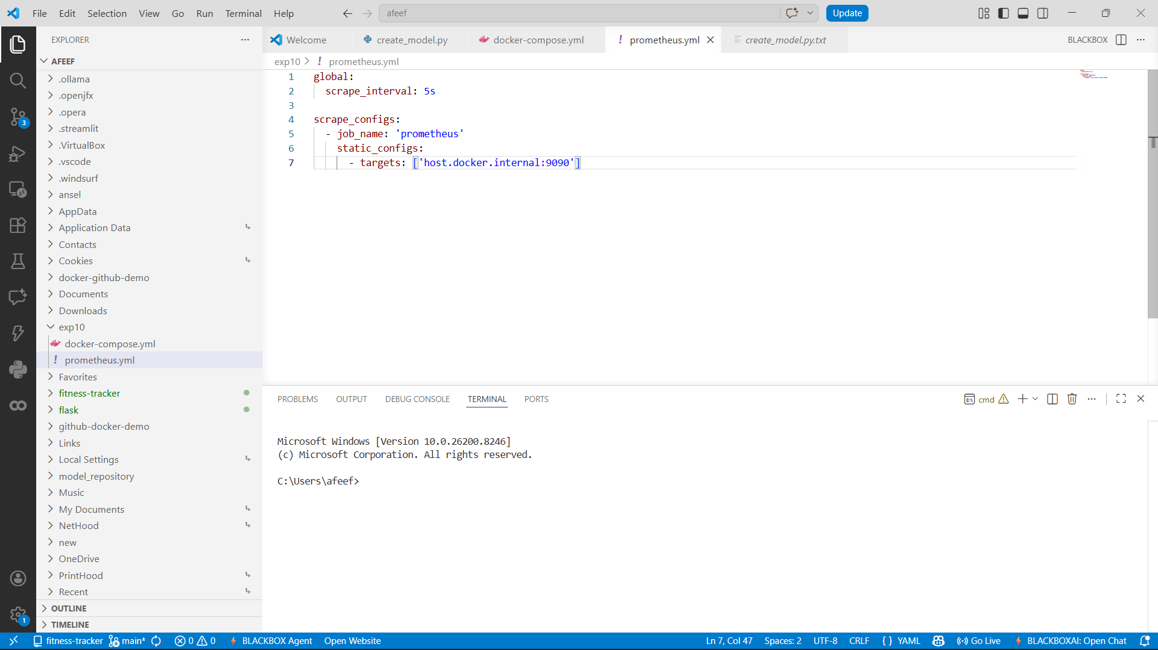

Fig 61:Prometheus Config File

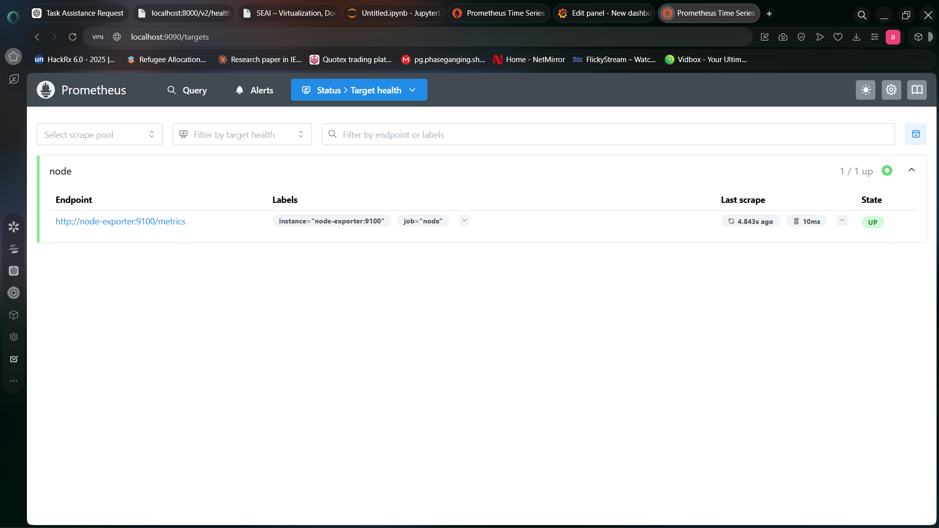

Fig 63:Prometheus Target Health Status

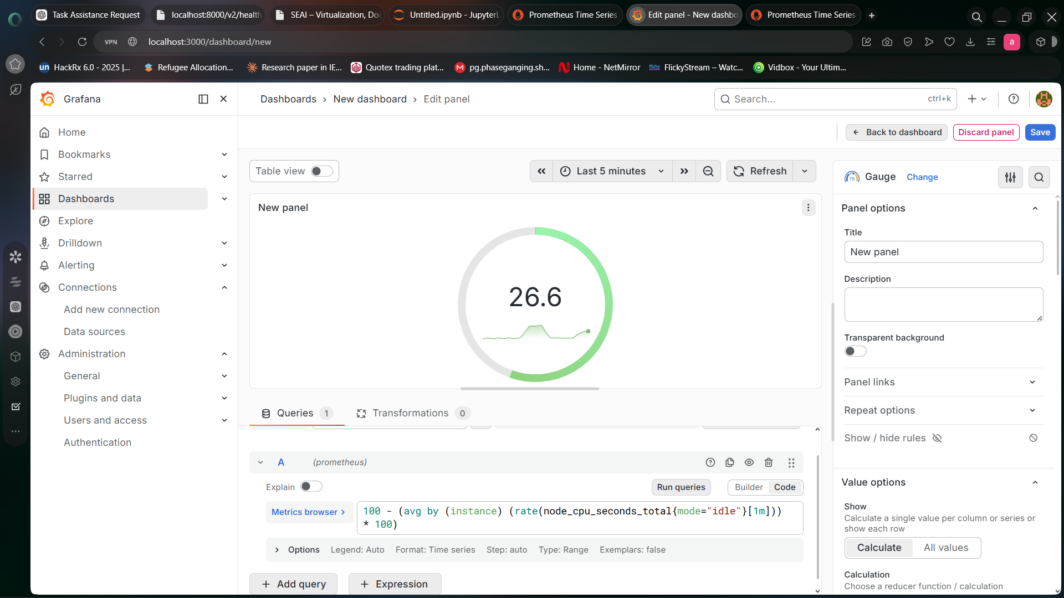

Fig 64:Grafana Monitoring Dashboard

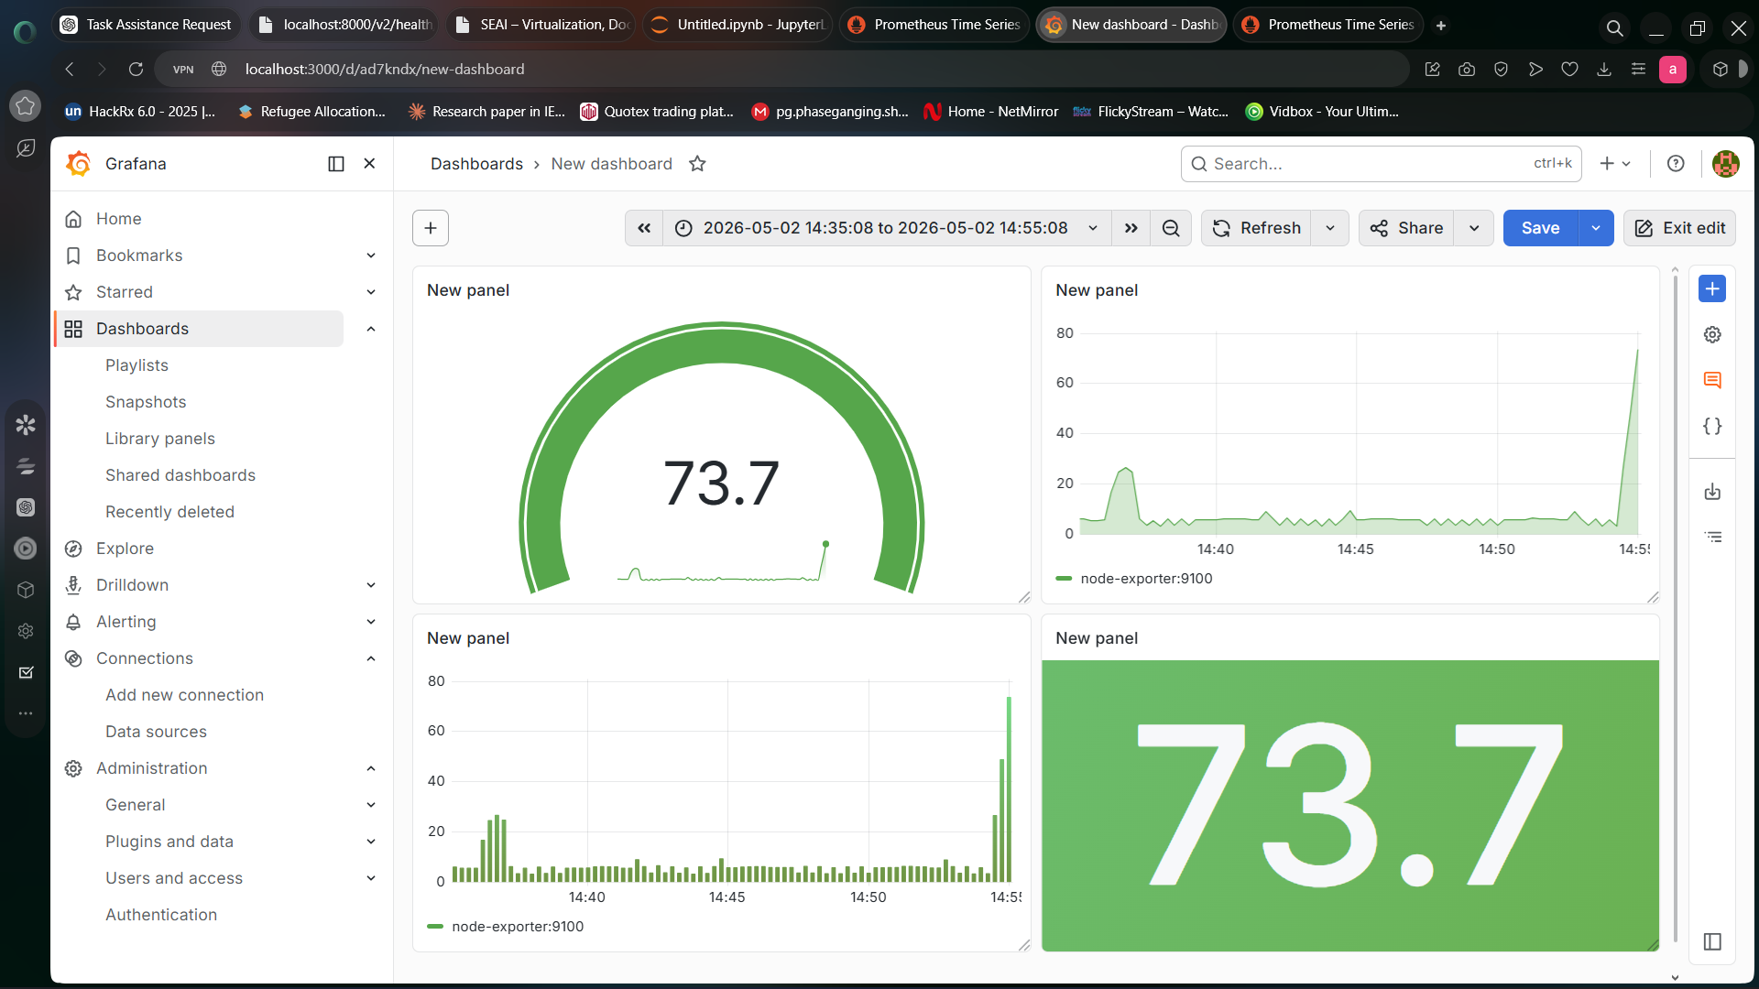

Fig 65:Grafana System Metrics Dashboard
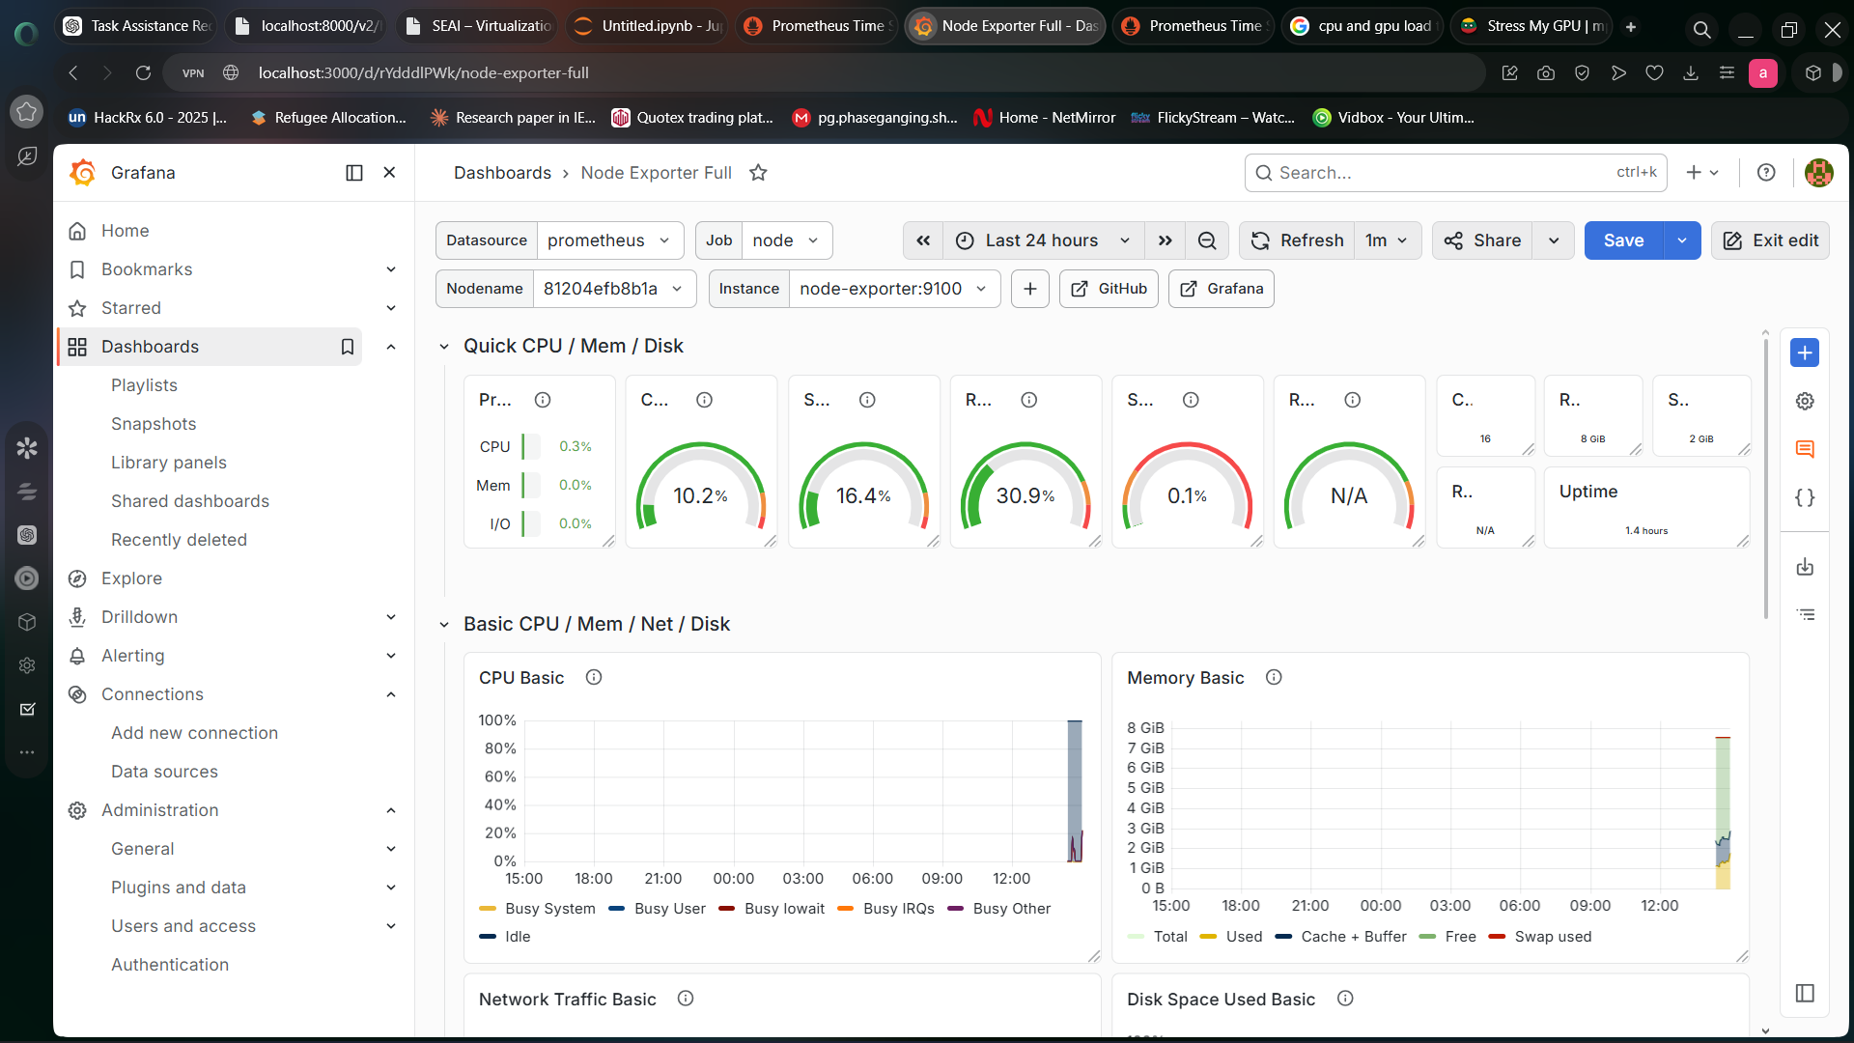

Fig 65:Grafana System Metrics Dashboard

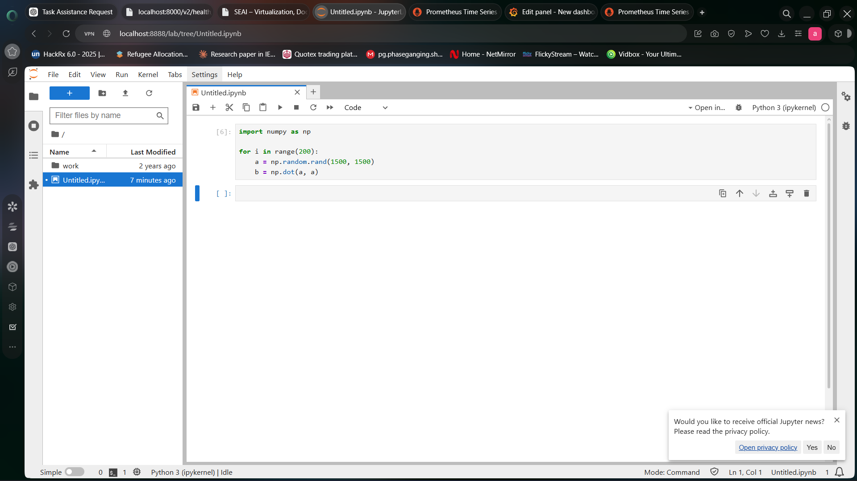

Fig 66:Jupyter Load Test Script

The services were started using:

docker compose up

The services were accessed through:

http://localhost:8888
http://localhost:9090
http://localhost:3000

A computational workload was generated in Jupyter.

import numpy as np

for i in range(200):
a = np.random.rand(1500,1500)
b = np.dot(a,a)

The CPU usage increased and was visualized in Grafana dashboards, demonstrating real-time monitoring and load handling.

